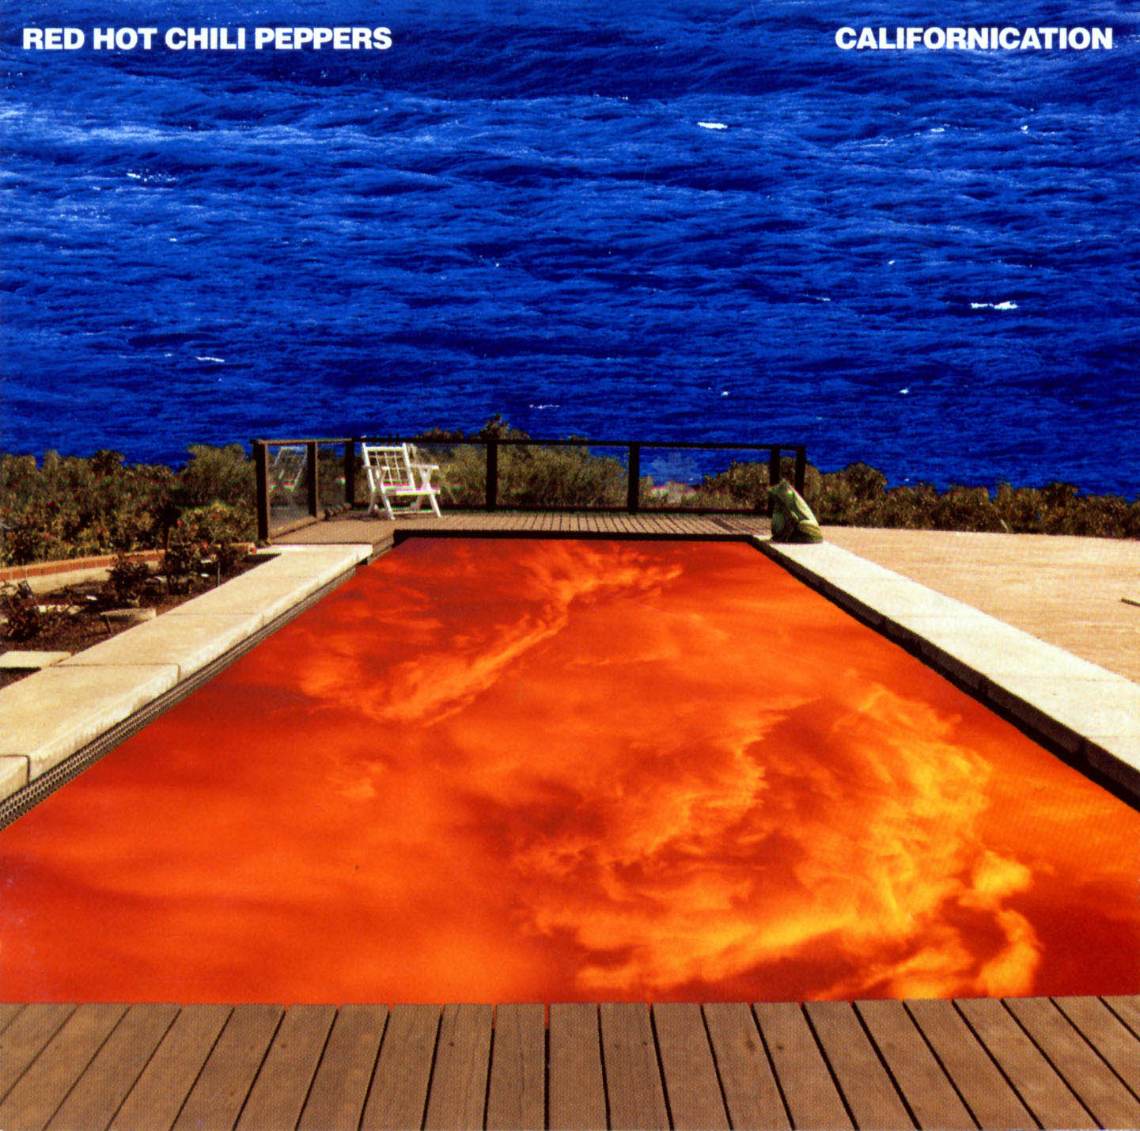

**Name:** Californication

**Band:** Red Hot Chili Peppers

**Trailer (Music Video):** <https://www.youtube.com/watch?v=YlUKcNNmywk>

**Genre:** Adventure / RPG

**Mechanics:** GTA 3D Sandbox style

**Objective:** To survive as the world becomes california

**Story:** The west may be the final frontier but its made in a Hollywood basement, and as psychic spies from china try to steal your minds elation there are little girls from Sweden who dream of silver screen quotations, and if you want these kinds of dreams its californication. It’s the edge of the world for all of western civilization, as the sun may rise in the east it always settles in its final location, and it is understood that Hollywood sells Californication.

**Environment:** California, anywhere and everywhere as long as its in California.

**Challenges/Encounters:** Driving in LA traffic, snowboarding the Golden Gate Bridge, surfing on a shark, climbing a redwood tree, riding a mining cart through an old abandoned gold mine.

**Player Characters:** Players may choose to play as any of the band members from the Red Hot Chili Peppers, these include: Anthony, Chad, Flea, & John. All plays have 6 stats, these being: Drums, Strength, Stamina, Agility, Charisma, & Rhythm.

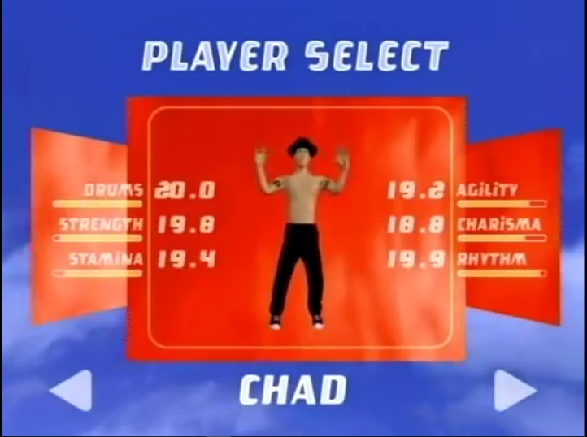

**Non-Player Characters:** Actors, directors, pornstars, musicians, agents, producers, managers, middle-men, drivers, pedestrians, construction workers, pilots, and hippies too.

**Achievements:** To collect all of the red stars. 

**Win Conditions:** To survive and find the mystical floating square in the middle of the earth which turns your video game characters into real life representations.

**Loose Conditions:** When the player dies. The player dies by running out of health points, or running out of oxygen (while swimming underwater).

**Map:** 